Table of Contents
Contents
Table of Contents 1
Introduction 2
Payment 2
Definition of Profits 2
Conditions for Revocation of Profit Share 3
Legal Stuff and Profit Distribution Logistics 3
What I Expect From You 4
General Artstyle 4
Sprites 4
Steam Thumbnails 6
Other 6
How to Get Started 6
Resources 7
More Details About the Game 8
What I Have So Far 8
Genre details 9
Closing Thoughts 11
About me 11

Introduction
I’m developing a survivor-like (aka term twin stick shooter or Vampire Survivors clone) to sell on Steam for $5-$10. I have little artistic talent, so I’m looking for a 2D artist to help out. If you’re reading this, it means I’m hoping you’ll be that person, and I want to give you a detailed overview of the project!
The estimated length of the project is 3 months, but I am admittedly terrible at estimating the time needed for large projects, so who knows?

Payment
Since I have no money, I cannot pay you a wage/salary. What I can do is offer a percentage of the profits. If that’s a dealbreaker for you, I totally understand, as this is expected to be a large time investment.
I’m expecting 2 people to work on this project, 3 if I decide I can’t do the audio by myself. I’m offering the following profit distribution:
- Me: 75%
- Art person: 25%
Or if I need an audio person:
- Me: 50%
- Audio person: 25%
- Art person: 25%

Definition of Profits
It costs $100 to publish a game on Steam, which I will pay out of pocket. Afterwards, a modest percentage of the sales revenue goes to Steam, and the rest goes to me. So profit will be any of the money given to me by Steam after they take their cut and apply any of their taxes. HOWEVER, the first $100 will go only to me to offset the publishing cost.
When the game reaches a sales revenue of $1000, Steam will refund the publishing cost. This refund will be distributed as normal profit.

Conditions for Revocation of Profit Share
I hope it won’t come to this, but I feel obligated to clarify that I can’t just give 25% of my profits to anyone that gives me a promise. But I don’t want you to feel like if there’s a miscommunication or something that you risk losing all of your share. I intend to be pretty lenient.
I do expect high quality sprites for all the items mentioned in the “What I Expect From You”->”Sprites” section as well as nice Steam thumbnails (which you can probably just make using Ansimuz’s assets). If you give me only some of what I need, I’ll still give you what I think is fair compensation.
I understand that miscommunications occur, life gets in the way, all that. I don’t expect this project to be smooth sailing all the way through for anybody. Even if you only give me like 75% of what I asked for I’ll still probably give you the full 25% as long as I’m convinced you aren’t deliberately trying to take advantage of me.
If all this wishy-washy subjective trust-based stuff bothers you, we can try to iron it out in more concrete terms.

Legal Stuff and Profit Distribution Logistics
Because (a) I do not own a corporation and (b) I am not a lawyer, you’re collaborating on this project at your own financial/legal risk. It is my understanding that we are to consider revenue from this project as “self-employed” revenue for taxes, though of course it varies based on where you live.
The easiest way to distribute profits for me would be to just Venmo the art person/audio person their share at a standard interval- I believe Steam pays monthly so a monthly interval would make sense. If you want me to check outside of the interval to see if there’s any money waiting for you that’s fine, I just don’t want to check every day.
If you’re not comfortable trusting a stranger with your money, I totally understand that. We can try and work something else out, maybe a legal contract or maybe even Steam can handle it for us. I haven’t done the research to know all the options but I’m sure we can find a method that everyone’s happy with.

What I Expect From You

General Artstyle
Currently I’m expecting the graphics to be generally 16-bit (or pseudo hi-res) style pixel art, though a mix of pixel art and hi res splash art such as in Shantae and the Pirate’s Curse would be cool.
Games with this style of art include:
- 20 Minutes Till Dawn
- Hammerwatch
- Various Shantae games
- Terraria
- Loop Hero
- Slice & Dice
- Songs of Conquest
- Rogue Legacy
- Spellbook Demonslayers
- Wings of Vi
- Legend of Keepers
This style is my preference, but if there is another style that would be easier for you I may be ok with it.

Sprites
For all sprites, I’ll send you details about them when they’re ready, unless you have an idea you’d like to work on.

Weapons
Every weapon will need to have its own sprite, whether a sigil on the floor, a bullet, or a sword slash. Some of them should preferably be animated, though I don’t expect more than like 5 frames. (I mean even smash ultimate only has like 5 frames for some of its attack animations.)

Enemies
Enemies each need their own sprites. I’m not sure how many enemy types I’ll have, maybe like 5-30, with 1-10 bosses. It depends on how much time you need to draw them and how much time it takes me to design them. Enemies can be pretty simplistic and non-animated, as long as they match the rest of the game’s artstyle.

Playable Characters
Playable characters (5-10?) need their own sprites. I’ve decided I want all playable characters to be women, and at least half of them to be sexy/half-naked. Some clarifications on what’s “too sexy” for this SFWish game:
Preference for stylish-sexy, not fanservice-sexy. Think something Bayonetta would wear. Or like Helltaker’s Judgement.
- No cameltoe or nipple imprints
- Avoid impossibly disproportionate sex appeal like Chun Li or Cordelia from Dead Estate
- Impractical armor ok
  - Including boob shaped breastplate
- Short skirts & upskirt shots ok
- Fighting in heels fine
Good outfit examples:
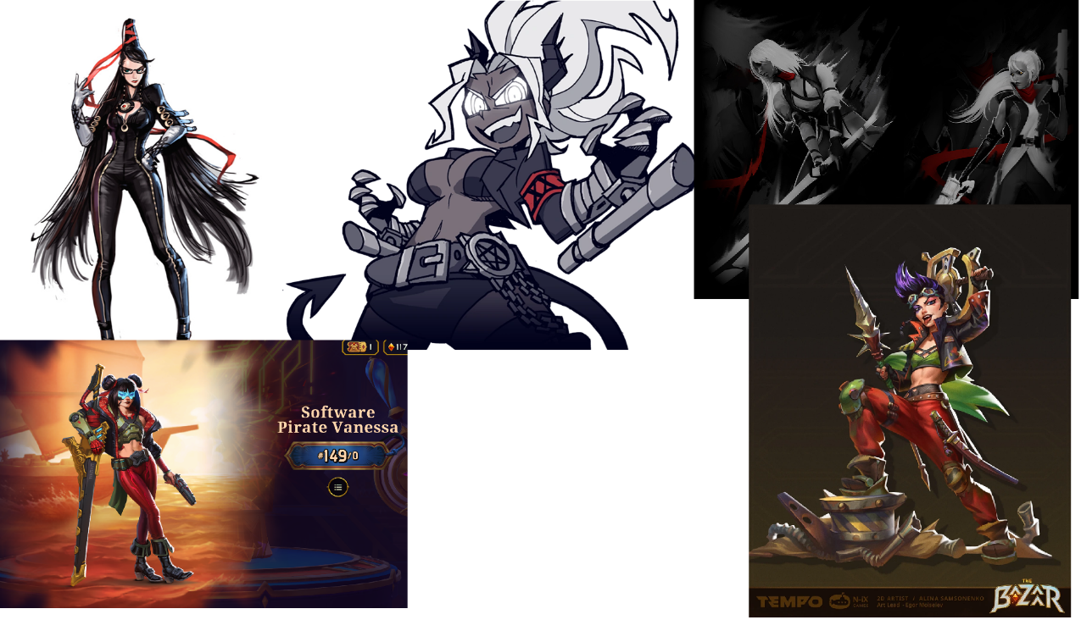
More practical/modest clothes also fine, as long as it’s stylish!
These characters should be animated, but just a simple run cycle is probably fine.

Maps
Each map (3-5?) will need artwork. As with most other survivor-likes they’ll just be large rectangles with few notable features (just a few trees or rocks here and there). I’m not totally sure what the best way to handle this is- one 30,000x30,000 picture? Something created directly in the editor? I’ll have to look into that. But I do expect there will be a lot of tiling, and the maps really don’t need to look that different.

Steam Thumbnails
There are quite a few ~10? thumbnails of various sizes that Steam requires to publish a game. I’ll need each of those, but I’d hold off until the game is nearly finished.

Other

UI
Menus, buttons, and UI would be appreciated. That sort of stuff is usually done in the Unreal Editor, but you could give me something to start with (like a background, border, and font for a textbox) and I can try to implement it.

Unreal Engine Integration
You don’t have to learn the engine/integrate anything into the game, just .png files are fine!

How to Get Started
If you have any ideas for weapons, characters, maps, etc. that you think would be cool, let me know and if I like it you can work on it!
Alternatively, you could just wait for me to design some stuff. To start, here’s a weapon for you:
Firebolt/Fireball
- Single fiery orange projectile
- Medium-small size in game
  - ~16x16-32x32? Not too picky but it should match other projectile sprites.
- Circular, but with a fire trail
- Moderate projectile speed
- Explodes on contact, dealing moderate damage in an area
- Applies a low damage burn dot on all effected enemies
So, you could ask me for more details on the fireball, or you could draw a sprite for me and send it my way!

Resources
Do not use AI to generate art. I don’t personally have a problem with it, but the customers most certainly do.
The game’s source code and everything else related to it is currently stored on GitHub:
https://github.com/NauPhy/i_love_vampires
You’re free to use any CC0 assets or other assets with “free to use and sell” licenses. The real challenge there is making sure they’re high quality and the art style is consistent with the rest of the game. Just make sure that if they require attribution, you write down the source so we can put it in the credits later.
Here are some of the CC0 assets I found useful in my first game:
- Dungeon Crawl Stone Soup – most of the sprites in Incremental Dungeon. Not the best quality imo but could still be useful.
- 1-bit pixel icons
- Whimsy Hallow
- Kenney Fonts
- Kenney Input Prompts
- Idylwild’s Icons
- Ansimuz’s stuff – Probably the most common artist I’ve seen in games. I like their stuff :3

More Details About the Game
This is still very much a work in progress, but I do have some ideas about how to give this game its own identity:
- Rather dramatic theme/feel
  - Flashy
  - Bloody
  - Sexy
  - Similar theme to Bayonetta and Devil May Cry
- The meta progression will be primarily unlock based
  - Completing objectives during your runs will unlock new weapons, passives, maps, etc.
  - Each character will have their own unlocks for completing objectives while playing as them.
    - Similar to the marks in Binding of Isaac
- The game will be very difficult
  - A lot of Survivor-likes are easy enough to beat within 3 or so tries after installing the game. That is boring imho.
  - Dying is intended to be fun.
  - Getting better at the game will not feel pointless.
  - 100%ing the meta-progression will not trivialize the challenge.
- Different playable characters will have interesting and unique abilities.
- Evolution mechanic
  - Many Survivor-likes (including Vampire Survivors) feature weapon evolutions: you reach a certain condition, and you can upgrade your weapon into a new form that is not only better but behaves rather differently too!
  - This game will have an evolution mechanic, but hopefully a bit more of a sophisticated one, like BallxPit’s “combination” mechanic.

What I Have So Far
My goal so far has been to learn the engine and create a fundamental framework of the game such that I can answer questions and give realistic expectations. I’m not in urgent need of art right now or anything- I still have a lot of work to do- but I figured now would be the best time to contact an artist, just to give them as much time as possible.
Here’s a video of what I’ve made so far. It touches on general gameplay structure, animated sprites, music and sfx, combatants, experience shards, and weapons.
https://www.youtube.com/watch?v=Buq4rJALQmE

Genre details
This section is not really important (which is why it’s at the end). I just figured some readers may not be avid gamers and may be unfamiliar with the genre.
Survivor-like is a fairly new subgenre of Action Roguelike with a rather specific set of gameplay elements. The name comes from Vampire Survivors. I’m not sure if Vampire Survivors was the first in the subgenre, but it’s certainly the one everyone knows about. My favorites from the subgenre are:
- Spellbook Demonslayers
- Brotato
- Soulstone Survivors
In brief, the parent genre Roguelike is characterized by:
- The game is fairly short and very random and is meant to be played all the way through multiple times.
- There are no checkpoints- if you lose you must start a new game.
- The core game is often wrapped in another content layer that offers some elements that persist after death/victory, such as achievements or unlocks. Also known as meta-progression.
  - A full playthrough of the core game is usually called a “run” to distinguish from a full playthrough of the wrapper.
Nearly all survivor-likes have the following elements:
- Singleplayer
- Action
- Top-down camera with player character locked in the center of the screen
- Runs take place in an arena
- Run lengths of 20-40 minutes
- The primary goal of the run is to survive until some condition is met (time, kills, etc.)
- Hordes of enemies spawn continuously and move towards you.
- Enemies get stronger over time.
- The typical way to survive is to kill enemies as fast as they spawn.
- Enemies drop experience shards on death, scaling with their strength.
- Collecting experience shards lets you level up (experience required increases with level). This is the primary way to get stronger.
  - When levelling up, you are presented with a choice of ~3 upgrades randomly drawn from a pool of dozens to hundreds of weapons and passive abilities.
- You start with 1-2 weapons, which trigger automatically on a timer. Through levelling up you can acquire a few more weapons, typically about 6 total.
- Weapons can be upgraded individually.

Closing Thoughts
If you have any questions, don’t hesitate to ask. And if you have any suggestions for theme, weapons, playable characters, or whatever else, I’d be glad to hear it. I accept that you’re not just more skilled than me in your area, but more knowledgeable too, and I don’t want to force you to do something if you think there’s a better way.
Oh, and if you need inspiration/more detail about the genre you could probably convince me to buy you a Survivor-like game. Especially Spellbook Demonslayers.

About me
Hello, my name is NauPhy. I’m 24 and hoping to launch a career in game development. I applied to a bunch of jobs and no one wanted me, so I decided to just make a couple of games myself and see how it goes. If they’re successful, I’ve got my dream job, if not, I’ll have to do something more boring.
My first game was Incremental Dungeon, which had pretty encouraging reception on Steam. It’s been 23 days since launch, and I’ve made about $200 profit. Given the 600 hours I spent on it that’s nowhere near a living wage, but it is free (with a $5 supporter pack) so that’s about what I expected. This next game will be the real test.

